**DIGITAL IMAGE PROCESSING**

**ASSIGNMENT REPORT**

**Prepared by:**

**Cheryl Toh Qiao Rou (20042206)**

**Jesrene Cheoy Ka Yan (20013546)**

**Yap Yi Rou (20057055)**

**Teo Yen Ting (20042834)**

**Table of Contents**

**1.0 Introduction** 2

**2.0 Methodology/proposed approach** 3

**2.1 Part A** 3

**2.2 Part B** 12

**3.0 Results and discussion** 18

**3.1 Screenshot of result** 18

**3.1.1 Part A** 18

***Screenshot 1 - face detection only*** 18

***Screenshot 2 - overlay talking video on blur face video*** 19

***Screenshot 3 - overlay watermark in the videos*** 21

***Sample output of all 3 videos after face blur and overlays*** 23

**3.1.2 Part B** 24

***Screenshot 1 - after apply adaptive thresholding to obtain binary image*** 24

***Screenshot 2 - after opening morphology*** 25

***Screenshot 3 - after drawing a rectangle on image*** 26

***Screenshot 4 - after closing morphology*** 27

***Screenshot 5 - after merging columns*** 28

***Sample output for image with 1 column*** 29

***Sample output for image with 2 columns*** 32

***Sample output for image with 3 columns*** 36

**3.2 Discussion** 42

**3.3 Limitations** 42

**3.4 References** 43

**3.5 Turnitin Similarity Report** 43

# **1.0 Introduction**

After completion of this assignment, we aim to gain full understanding of basic video processing and paragraph extraction. We will be applying the knowledge gained from the practical class of the course CSC2014 Digital Image Processing in this assignment to obtain the desired output for each task. This assignment is separated into two main parts, part A and part B. In part A, we are expected to process videos to be posted on YouTube. Processing techniques like face detection, blurring, overlaying, adding border and resizing videos and images will be done in this part. In the end of the assignment, we will produce three videos of different length in .avi format which is overlaid by another talking video and watermarks as outputs of part A. In part B of the assignment, we are expected to extract paragraphs from papers with different numbers of columns while ignoring tables present in the text images. There are 8 different text images with an altering number of columns and tables provided as the text images that need to be processed. At the end of the assignment, we are expected to detect the number of columns and extract each paragraph of all materials provided and sort the paragraphs into the correct sequence while excluding tables from the extraction process. By the end of this project, we should be able to utilize various libraries such as OpenCV and NumPy, understand how to resize videos, overlay videos with another video and watermarks, detect the number of columns and extract paragraphs from papers in Python.

# 

# **2.0 Methodology/proposed approach**

## **2.1 Part A**

In part A, the only library we used to obtain the desired output is opencv. The below are the list of cv2 methods used in our script:

|  |  |
| --- | --- |
| Methods | Function |
| cv2.resize() | To resize image and video |
| cv2.VideoCapture() | To capture video file |
| cv2.copyMakeBorder() | To add padding and border to image |
| cv2.imread() | To read image file |
| cv2.cvtColor() | To convert BGR to grayscale |
| cv2.VideoWriter_fourcc() | To set codec of video writer |
| cv2.VideoWriter() | To set up video writer |
| cv2.CascadeClassifier() | To implement Haar Cascade for face detection |
| cv2.GaussianBlur() | To blur faces |
| cv2.CAP_PROP_POS_FRAMES() | To get current frame position |
| cv2.CAP_PROP_FRAME_COUNT() | To get total frames of video |
| cv2.imshow() | To show images |

**Video Writer**

The first thing that happens after calling the function is setting up a video writer where details of the output video is initialized. Looking at the code, the codec used is XVID with 30 fps in resolution of 1280x720.

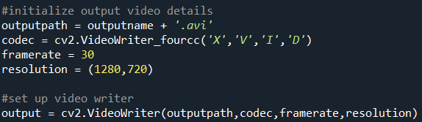

**Video Capture**

After that, video capture is set up and a while loop is started if the video window is open. Frame of the video is then read frame by frame using the method “capture.read()”.

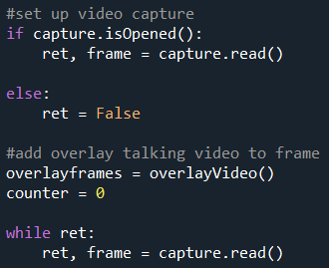

To understand the theory behind this, the below figure shows a visualized version of the code. The video reader only reads the next frame when there is a next frame, which is identified by a boolean variable “ret”.

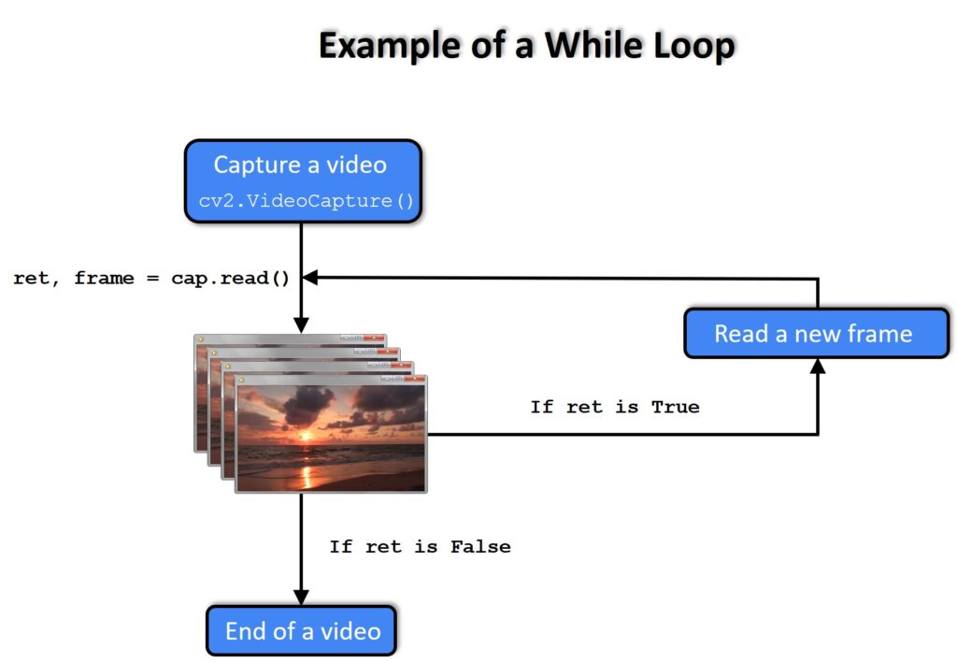

**Face detection and blurring faces in video**

In the while loop, the first process we did was face detection using the Haar Cascade which the algorithm is provided as “face_detection.xml” on elearn. We first resize the frame by calling the “resize()” function we created which will be further explained here. Then, the frame is converted into grayscale for easier analysis of Haar Cascade. After that, we cascaded the Haar cascade with the method “cv2.CascadeClassifier” and store the detected faces areas into an arraylist where we use the function “detectMultiScale'' to enable Haar cascade to detect multiple sizes and numbers of faces. Tweaking the scale factor and minimum neighbors count will adjust the sensitivity and accuracy of the face detector, hence having minimum neighbor count as one of the parameters of the function to be parsed will identify the sensitivity of the face detector to each video to be processed. After detecting faces in the video, a gaussian blur effect is then applied on the faces detected.

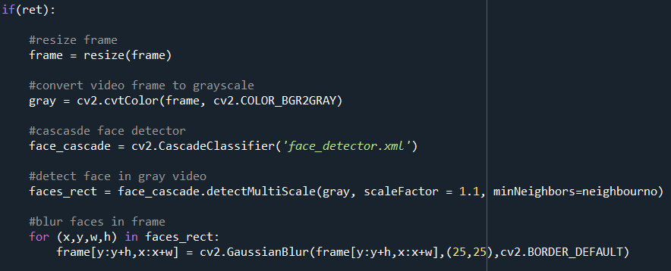

The figure below shows the flowchart of how haar cascade and blurring of faces work

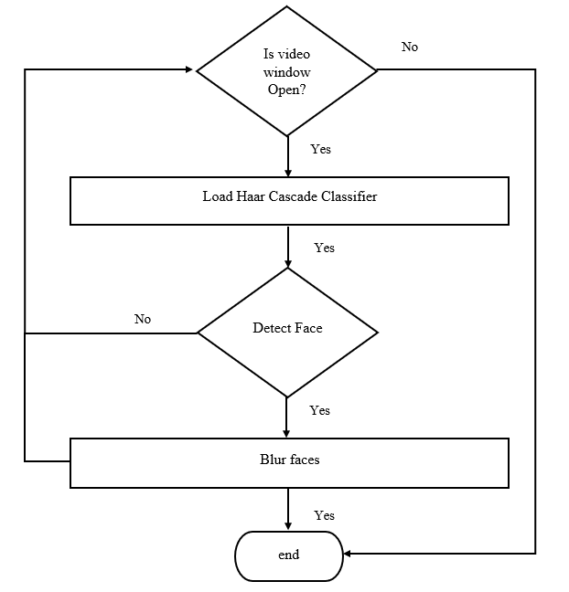

**Overlaying video onto video**

After blurring faces, we then overlaid “talking.mp4” onto the frames. We first called the overlayVideo() function to get the returned frame list of the overlay video. Details of the function are explained here.Then we initialized a counter to indicate if there is any frame left in the frame list that has not been overlaid.

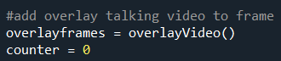

In the while loop, we overlaid each frame of the talking video onto the current frame of the background video. The counter is incremented after each frame is overlaid to enable overlaying of different frames for each iteration of the while loop. If the while loop is still iterating while the talking video runs out of frame, the counter is reset to 0 to overlay the first frame of the talking video, creating a loop effect of the talking video in the output.

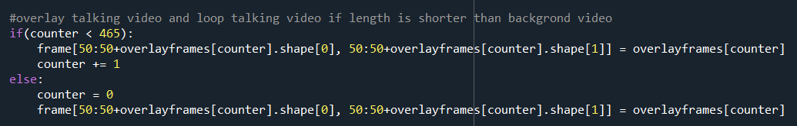

The figure below pictures the flow of overlaying video:

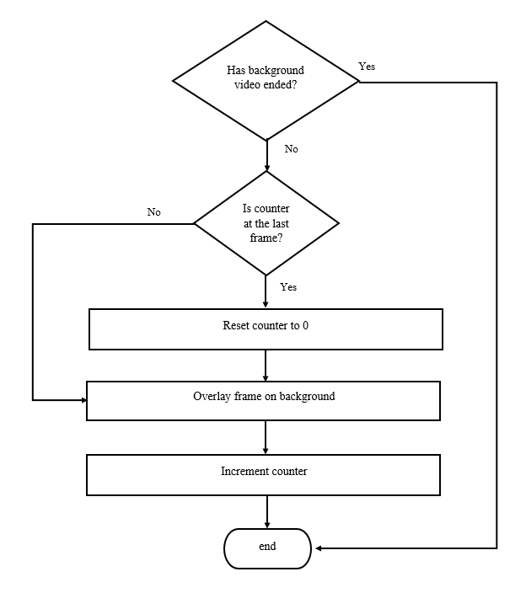

**Overlay watermark on video**

The next part of the process() function is to overlay watermarks on the video. The first half portion of the video is overlaid with watermark1 while the other half of the video is overlaid with watermark2. The overlaying of water is its own function which is explained here. In the while loop, we use cv2.CAP_PROP_POS_FRAMES and cv2.CAP_PROP_FRAME_COUNT to obtain the position of the current frame and total number of frames of the video. We then use an if-else statement to know which portion of the video is the current frame located, then call the respective watermark functions to overlay correct watermark on frame.

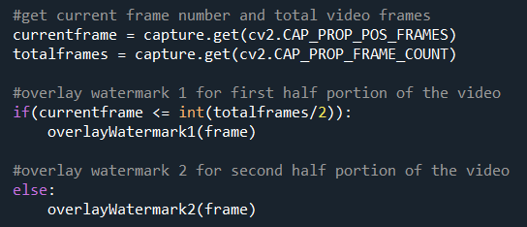

**Writing and showing output**

The next part of the process() function is writing the frame into the desired file path and showing the frame using cv2.imshow(frame). The if statement in the code snippet below means that the video will stop (break out of the while loop) when there is no frame left or when the user presses “d” on the keyboard. The video window will be terminated automatically after the entire video is played and video capture and writer is released.

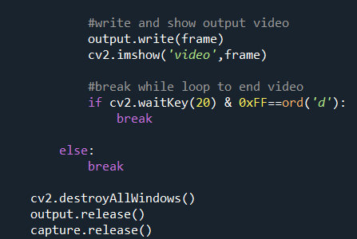

**Process overlay video**

Before overlaying the “talking.mp4” video onto background video, we did some processing to the video. The processing of the talking.mp4 video is done as another standalone function called “overlayVideo()”.

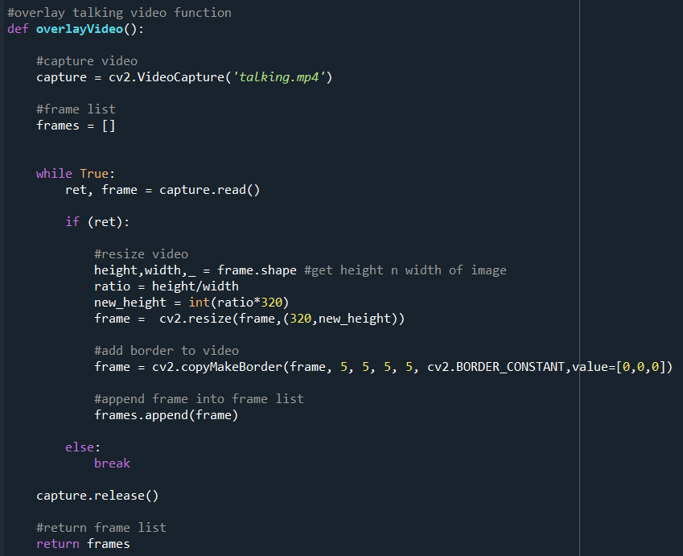

In this function, we aim to get the overlay video ready to be overlaid onto the background videos. We first captured the video and created a list to store each and every frame of the talking video. Then, we started a while loop to read the frames of the video. Each frame is resized to desired size and a border is added to the frame using “cv2.copyMakeBorder”. The frame is then appended into the list created earlier. Once all frames of the video are stored, this function returns the list of frames to be overlaid onto the videos.

**Overlay watermark function**

We created different functions for different watermark overlays. The content of both the functions are the same except for the watermark it reads.

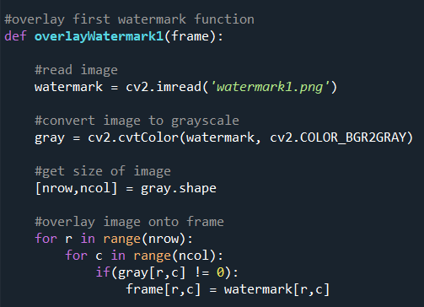

A frame parameter is required when calling the watermark function to indicate the background to be overlaid. In the function, we first read the watermark image. Then the image is converted into grayscale. The size of the image is obtained. A global threshold of 0 is set to detect if the particular pixel is the watermark (foreground) or background. A for loop is started to iterate through every pixel of the watermark image, if the pixel intensity is not 0, which means that it is a foreground pixel. The same pixel of the background frame is then replaced by the pixel of watermark to create an overlay effect.

**Resize function**

To resize each frame into the desired resolution upon writing output, we created a resize function which requires a “frame” parameter. The function calculates the ratio of the width and height of the frame and gives the frame a new height following the desired width.

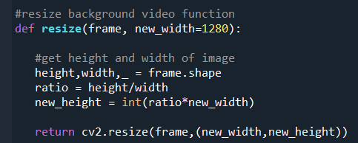

**Hardcoding**

After creating functions needed to complete the video processing process, a minimal amount of hardcode is needed to complete part A. We first hardcoded the capture of all background videos, then called the process() function a few times, parsing in values needed like video captures, output file path and number of minimum neighbors for face detection.

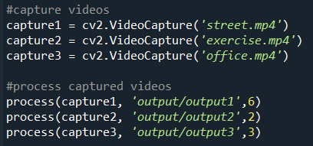

# 

## **2.2 Part B**

In part B, the libraries that we used to produce the desired output are opencv and numpy. The below states the methods used in our script for both mentioned libraries:

OpenCV

|  |  |
| --- | --- |
| Methods | Function |
| cv2.adaptiveThreshold() | To produce binary image |
| cv2.findContours() | To find contours in image |
| cv2.copyMakeBorder() | To add padding and border to image |
| cv2.imread() | To read image file |
| cv2.cvtColor() | To convert BGR to grayscale |
| cv2.drawContours() | To draw contours on image |
| cv2.getStructuringElement() | To get desired kernel |
| cv2.morphologyEx() | To apply morphology |
| cv2.boundingRect() | To create approximate rectangle |
| cv2.rectangle() | To draw rectangle |
| cv2.convexHull() | To find convex hull of shape |
| cv2.resize | To resize image |
| cv2.imwrite | To write image |

Numpy

|  |  |
| --- | --- |
| Methods | Function |
| np.concatenate() | To merge 2 arrays together |

In the ignoreTable() function:

**Fill table with white color**

The first step to vomiting tables in text images to make tables into white rectangles by filling contours found. We first transform the text image into grayscale, then invert and form an inverted binary image. To form the inverted binary image, our approach is using cv2.adaptiveThreshold() instead of using histogram and manually thresholding and forming the binary using for loop. This is because by using adaptive thresholding, the result can be produced with just one line and the threshold value is often much more accurate than manual thresholding. Then, we find and fill contours with cv2.findContours() and cv2.drawContours() methods in order to fill the table to make it a white rectangle.

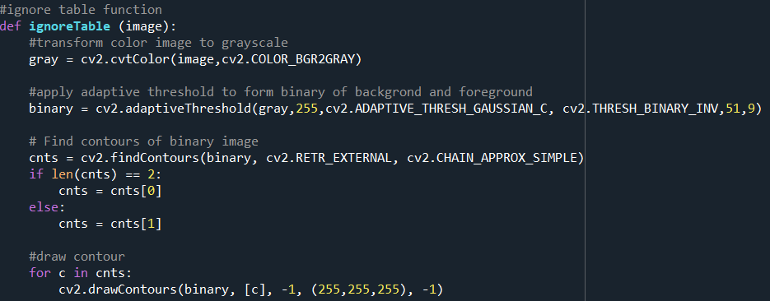

**Opening morphology**

In order to leave only tables in the binary image and omit all the texts, opening morphology is used. Opening morphology is basically a combination of erosion and dilation where the small noises are omitted through this morphology technique. The figure below shows image before and after opening morphology is applied:



In our case, we use opening morphology to first erode all texts leaving just the white rectangle in, then dilates the rectangle to its original size.

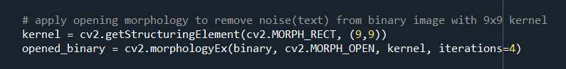

**Omitting table(s) from text images**

The last step to ignoring tables is to completely omit tables from text images. To do this, we first find the contours of the opened binary image, then following the contours we detected, draw a filled white rectangle onto the original text image. This way, the table that is on the original text image will be covered by a white rectangle which produces an illusion like the table has been removed from the original image.

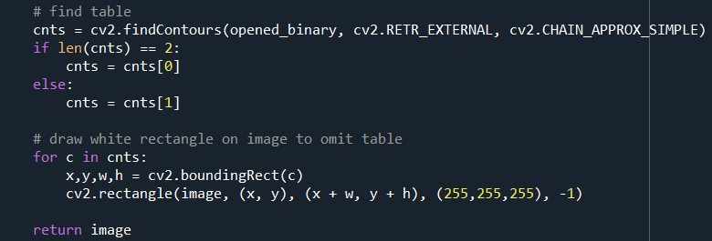

In the detectColumn() function:

**Create inverted binary**

After the ignoreTable() function, the output is parsed into the detectColumn() function to go through detection of the number of columns and merging columns to one. The first step is to transform the image into an inverted binary image.

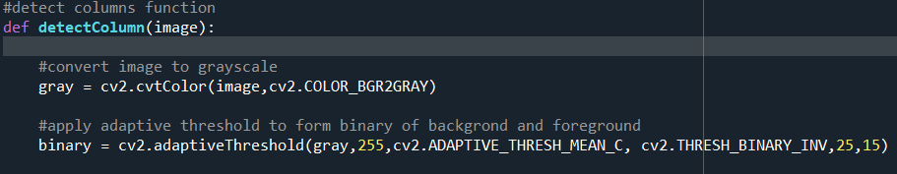

**Closing morphology**

To detect columns, we need to close the gaps between paragraphs but do not close the gaps between columns. We used closing morphology to first dilate the image to close all gaps within the kernel, then erode the image to obtain back the same thickness and borders. The figure below shows an example of closing morphology:



To obtain best output, the choosing of kernel size becomes extra important to make sure the dilation and erosion only happens within columns but do not merge more than one column together.



**Crop and merge columns to one**

After obtaining a closed binary image where columns are transformed into chunks of shapes, we use cv2.findContour() to obtain contours of columns. Then we started a for loop to loop through the contours we obtained. For images with more than one contour (more than one column), the convex hull of the contours are obtained to have a smoother extraction of columns.

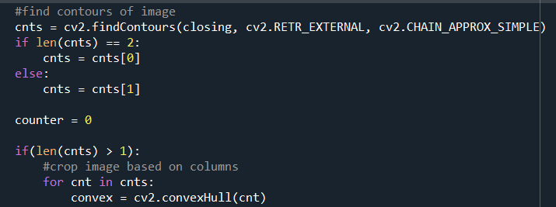

The process after this will be stated in point forms.

1. Each contours’ information like x-coordinate, y-coordinate, width and height is obtained and the information is applied padding to enable extraction of columns with white paddings

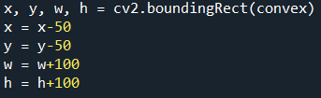

1. The column in contour is extracted and stored in a variable called “cropped”

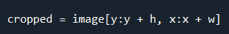

1. Previously, a counter was initialized. If the contour we extracted was the first contour of the image (check by seeing if length of contour does not change after subtracting counter value), we store a copy of the “cropped” column into a variable named “temp”

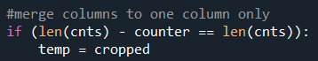

1. If the column we extracted was not the first column of the image, it means that the image stored in the “temp” variable is a column before the current extracted column, while the current column is stored in the “cropped” variable. We resize both “cropped” and “temp” columns to the same size.



1. Then, we concatenate both “temp” and “cropped” columns to produce an output of 2 or more columns merged into one column. Then the “temp” column is replaced by the merged output.

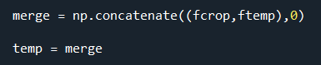

1. The counter is then incremented to indicate the current number of column extracted



1. The merged output is then returned at the end of the detectColumn() function

In the extract() function:

**Closing morphology**

In the extract() function, we extract and sort paragraphs into the respective file path. The first step to extraction of paragraphs is just like the previous function, to apply closing morphology to make paragraphs into chunks of shapes. The morphology should only happen within paragraphs but not merging more than one paragraphs together. In other words, the selection of kernel size is crucial to be able to extract paragraphs accurately.

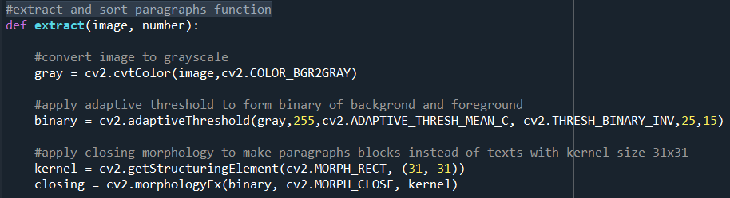

**Extracting paragraph**

After that, we obtain contours of all paragraphs. A counter is initialized for the convenience of naming the output image. A for loop is started and information of each contour is obtained. Following the information of the contour obtained, the portion of the image is extracted and store in a variable named “cropped”.

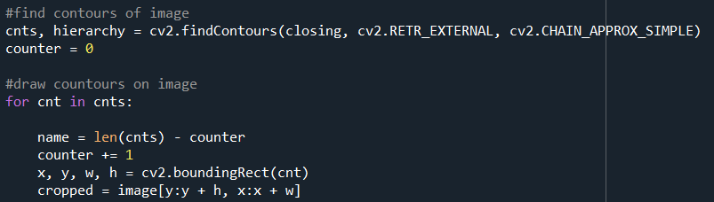

**Saving output**

After extracting paragraphs, we added padding to the extracted paragraphs to obtain similar output as the sample output given in elearn. The padded output is then written into the respective file path using cv2.imwrite(). A rectangle is then drawn to indicate which paragraph(s) is/are already extracted.

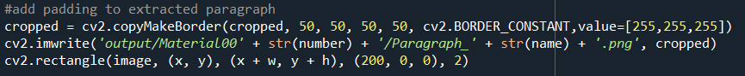

**Hardcoding**

After having all the functions ready, some hardcoding is required to perform processing of the mentioned functions to specific text images. We read the materials needed to be processed, then parsing them into the ignoreTable() function, followed by the detectColumn() function. Lastly, the outputs of detectColumn() function are then parsed into extract() function together with the number for naming of output file to obtain all desired output, extracting all paragraphs of the text images, sorted and stored in their respective folders.

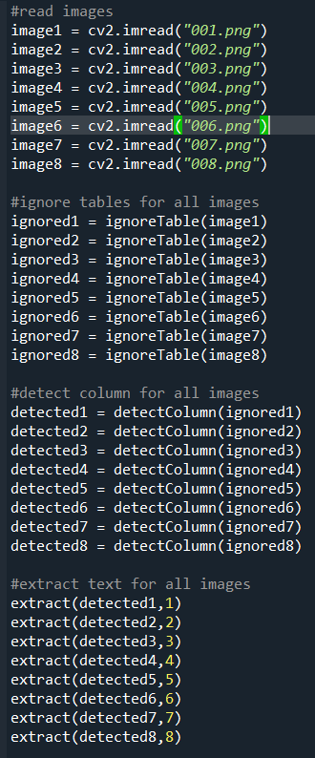

# **3.0 Results and discussion**

## **3.1 Screenshot of result**

### **3.1.1 Part A**

#### ***Screenshot 1 - face detection only***

Output:

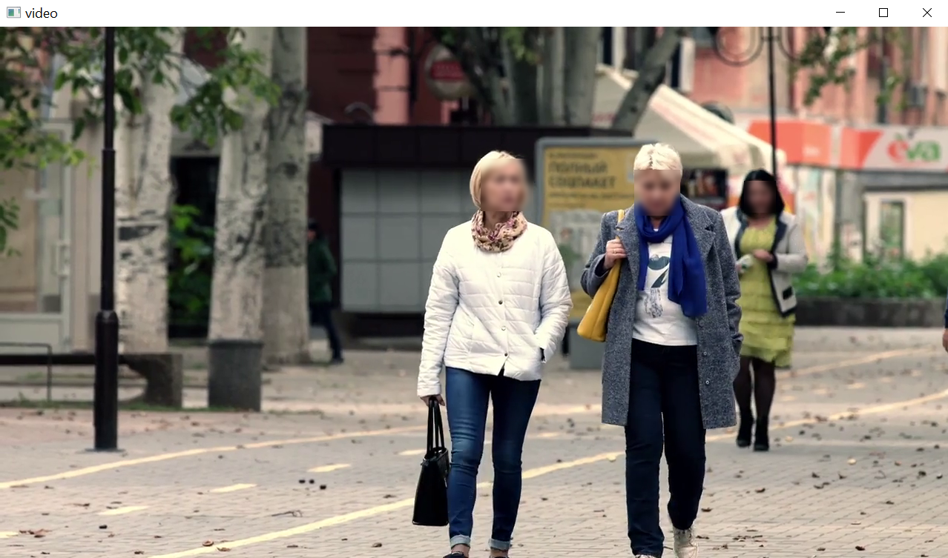

* street with face blur

Code snippet:

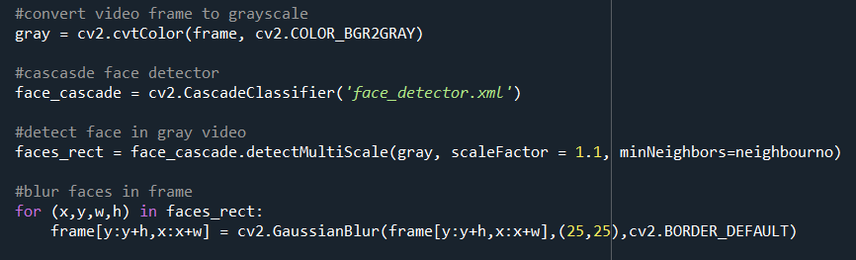

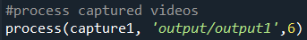

Summary:

The figure above shows the result after applying face blur to “street.mp4. The faces are recorded in the “face_rect” variable to be blurred with the Gaussian blur in kernel size of 25x25 pixels.

#### ***Screenshot 2 - overlay talking video on blur face video***

Output:

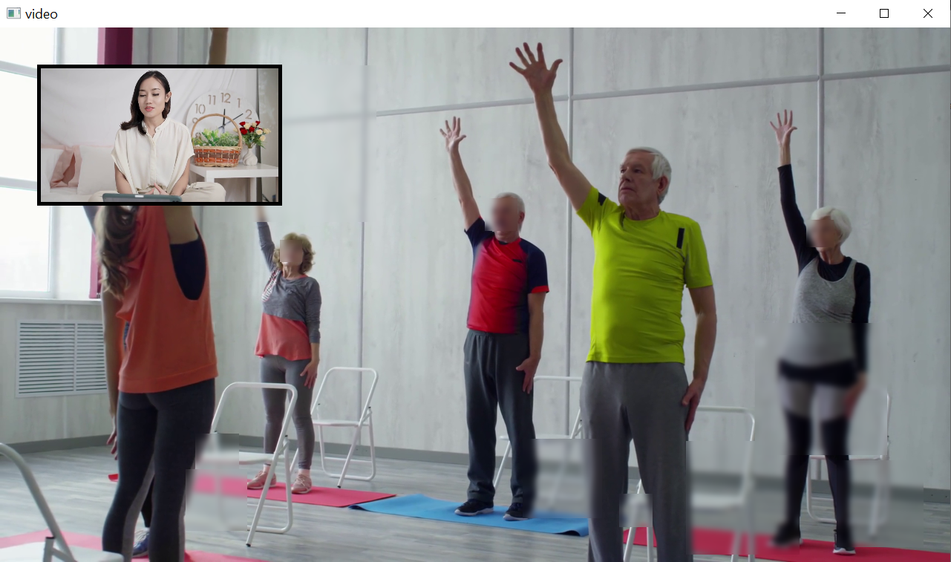

Code snippet:

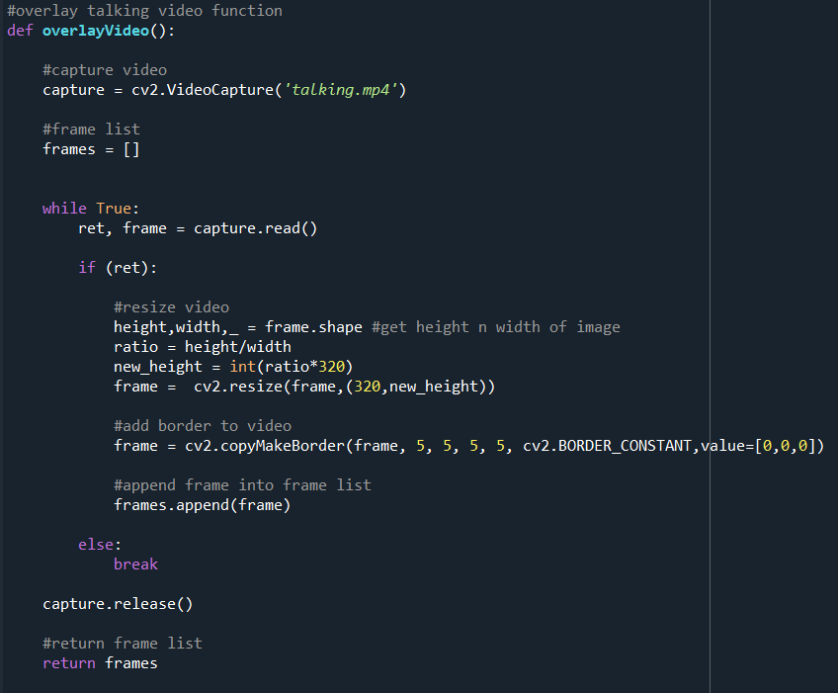

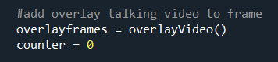

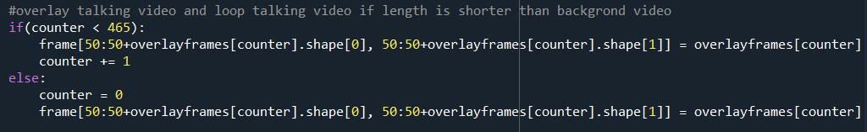

Summary:

An array list is created to store all the frames of the overlay video. The frames of overlay video are resized to desired resolution, added 5 pixels of the black border to surrounding regions, and then appended into the list. Counter is used to loop to overlay video if the length of background video is longer than the overlay video.

#### ***Screenshot 3 - overlay watermark in the videos***

Output:

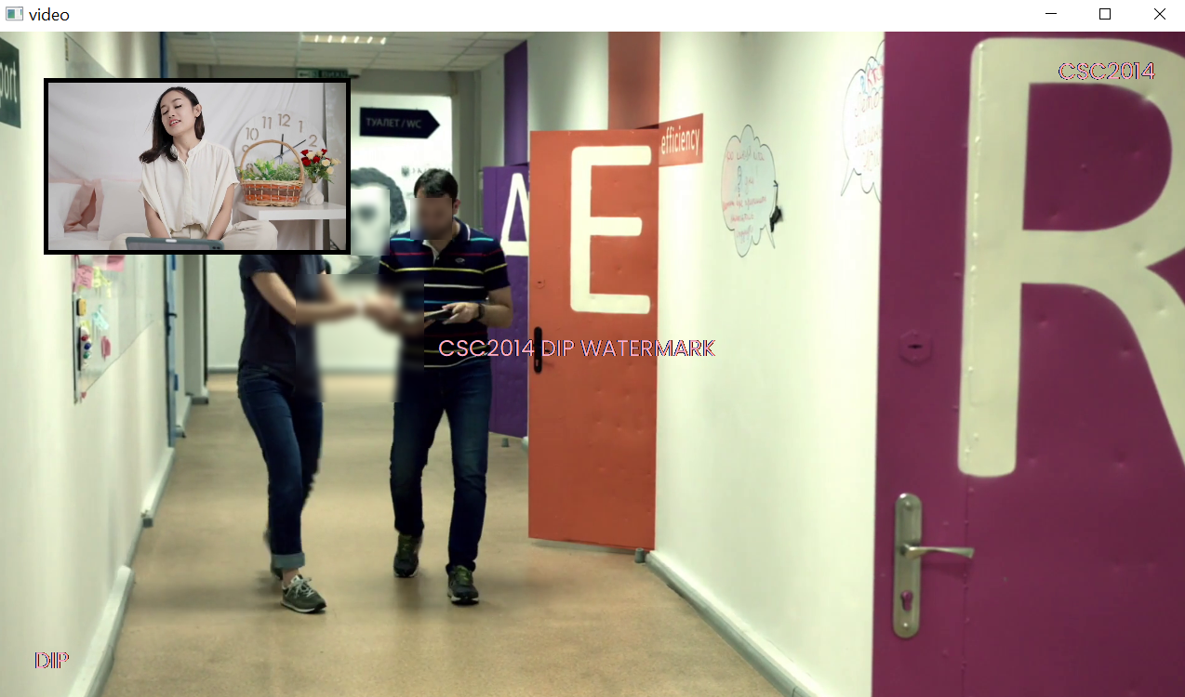

Code snippet:

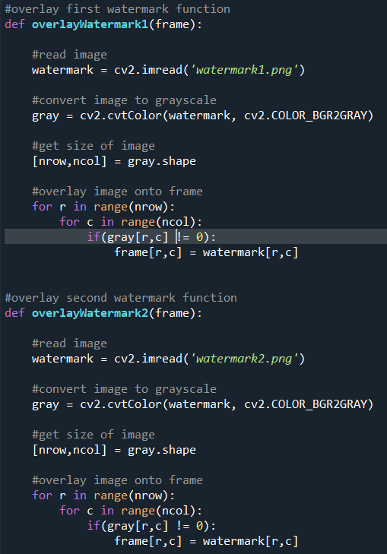

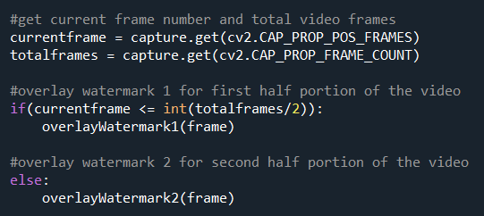

Summary:

Watermark 1 and 2 are overlaid on to background video through global thresholding. Pixels in the frame are navigated one by one, if the current pixel is not black color, the watermark's pixel will replace the pixel of the original frames, and vice versa. The total number of frames is obtained to ensure watermark 1 is showing in the first half of the video while watermark 2 is in the second half. From the sample output, watermark 1 is shown in the office frame.

#### ***Sample output of all 3 videos after face blur and overlays***

Output 1:

Filepath: Assignment\partA\output\output1.avi

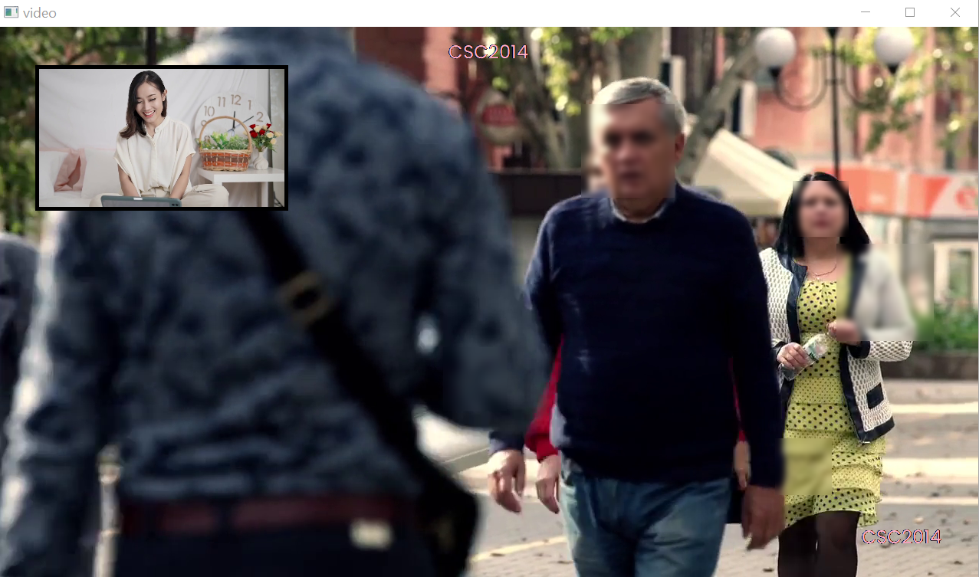

Output 2:

Filepath: Assignment\partA\output\output2.avi

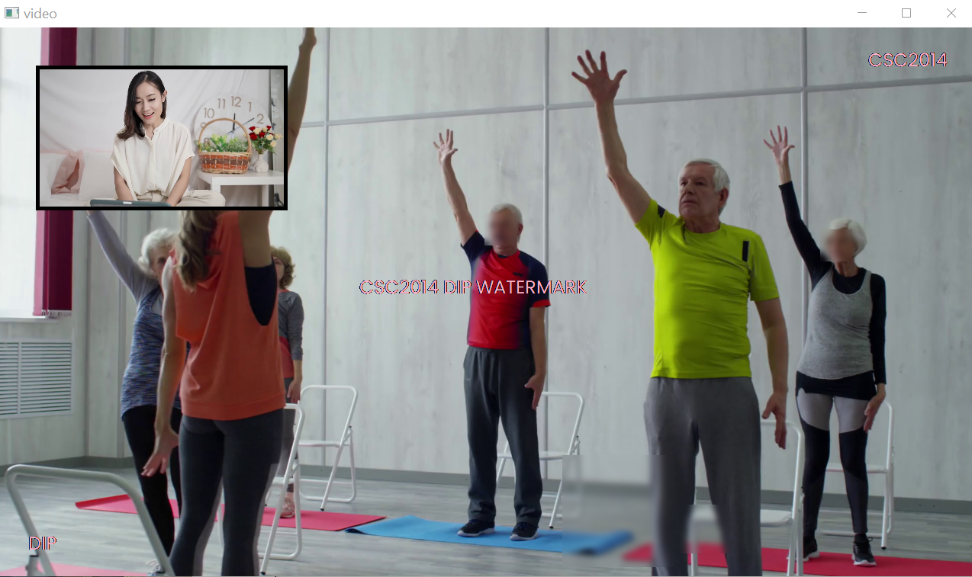

Output 3:

Filepath: Assignment\partA\output\output3.avi

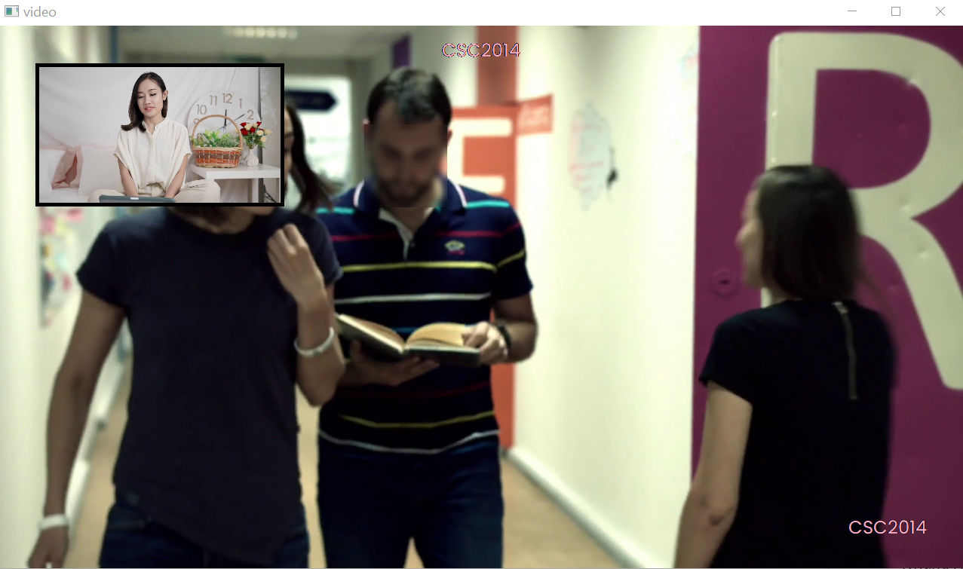

* office with face blur, overlay talking & watermark 2

### **3.1.2 Part B**

#### ***Screenshot 1 - after apply adaptive thresholding to obtain binary image***

Output:

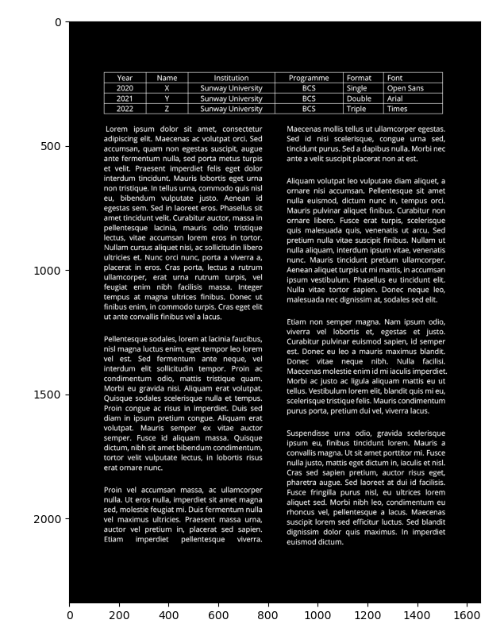

Code snippet:



Summary:

The figure above shows the image after applying adaptive threshold to form binary of background and foreground. After transforming the text image into grayscale, we formed an inverted binary image. The pixels that are white will be transformed into a black color, whereas the pixels with darker color, which in this case, would be the font, will turn into a white color.

#### ***Screenshot 2 - after opening morphology***

Output:

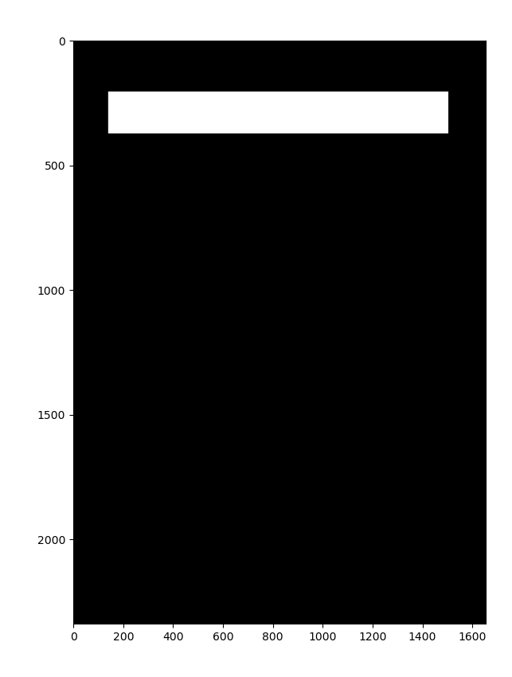

Code snippet:

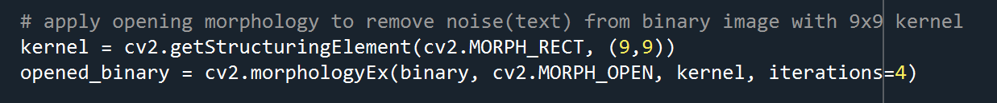

Summary:

By using the example from “004.png”, we can see that the section that is supposed to be a table becomes white in color. This happens after applying opening morphology and removing noise in the image, which in this case, the noises are texts from the binary image with the 9x9 kernel. Hence, only the table will be displayed from the image in an intensity value of 255.

#### ***Screenshot 3 - after drawing a rectangle on image***

Output:

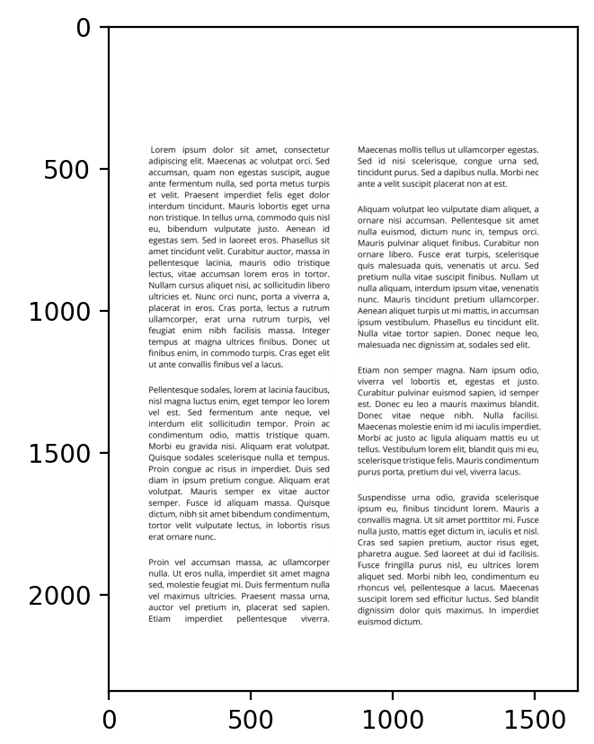

Code snippet:



Summary:

After finding the coordinates of the table by using cv2.findContours in the binary image, the for loop would store coordinates of the table and draw a white rectangle on the image to omit the table. This process will make it easier for each paragraph to be extracted out later on.

#### ***Screenshot 4 - after closing morphology***

Output:

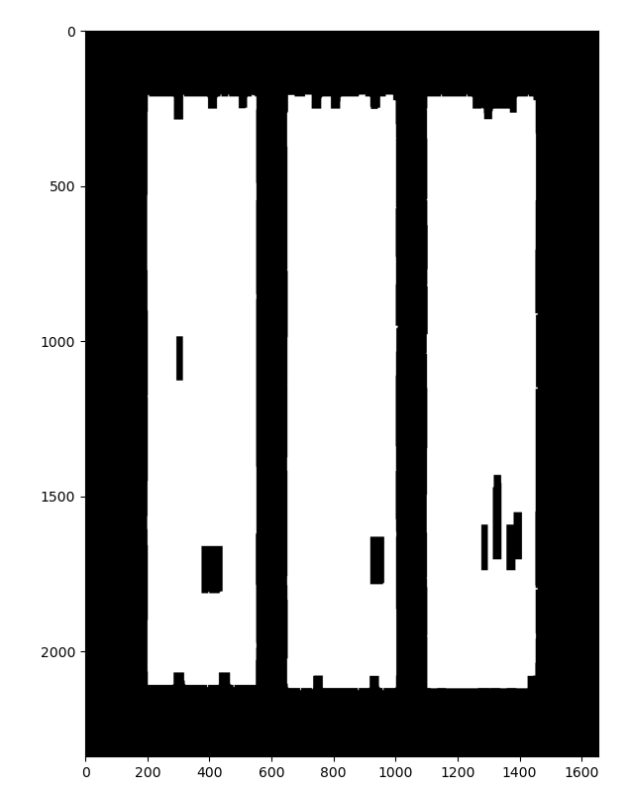

Code snippet:



Summary:

As shown in the figure above, the “005.png” has 3 columns of paragraphs that are combined into chunks of shapes using closing morphology. This method is used to remove small dark spots and connect paragraphs in the same column together to make the extraction process easier.

#### ***Screenshot 5 - after merging columns***

Output:

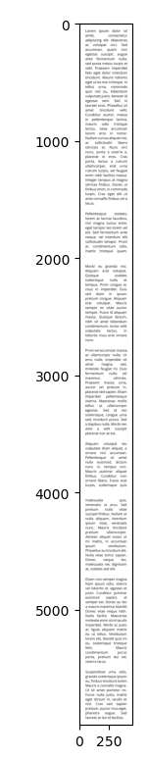

Code snippet:

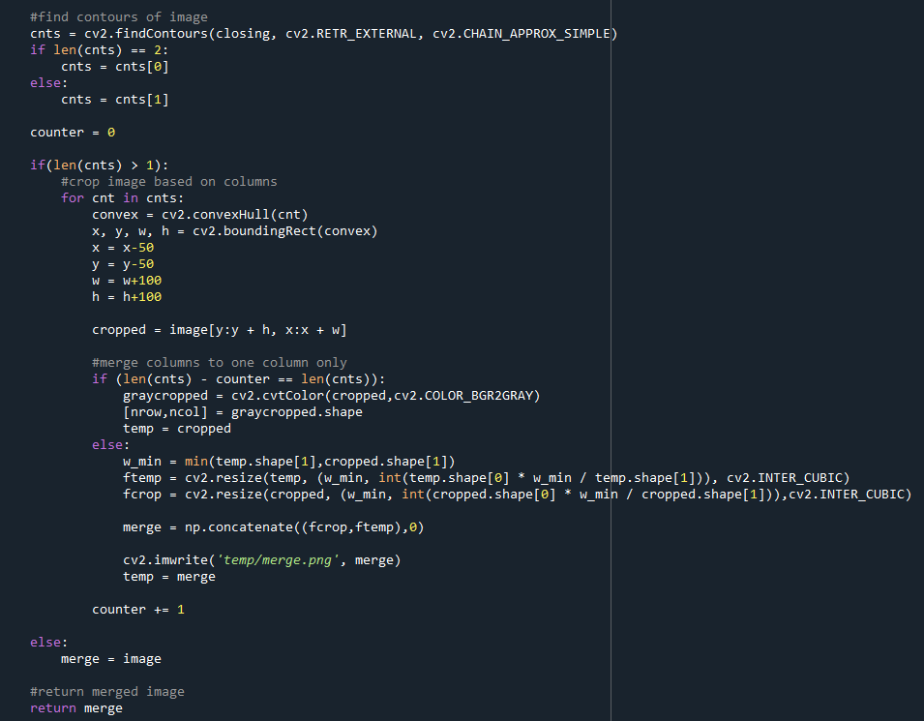

Summary:

After finding contours of the newly formed white chunks, each column is extracted and merged with the columns before the current extracted column to form an image with one column only. This is to make extraction of paragraphs easier with paragraphs sorted out nicely.

#### ***Sample output for image with 1 column***

filepath: output/Material001

Before extraction:

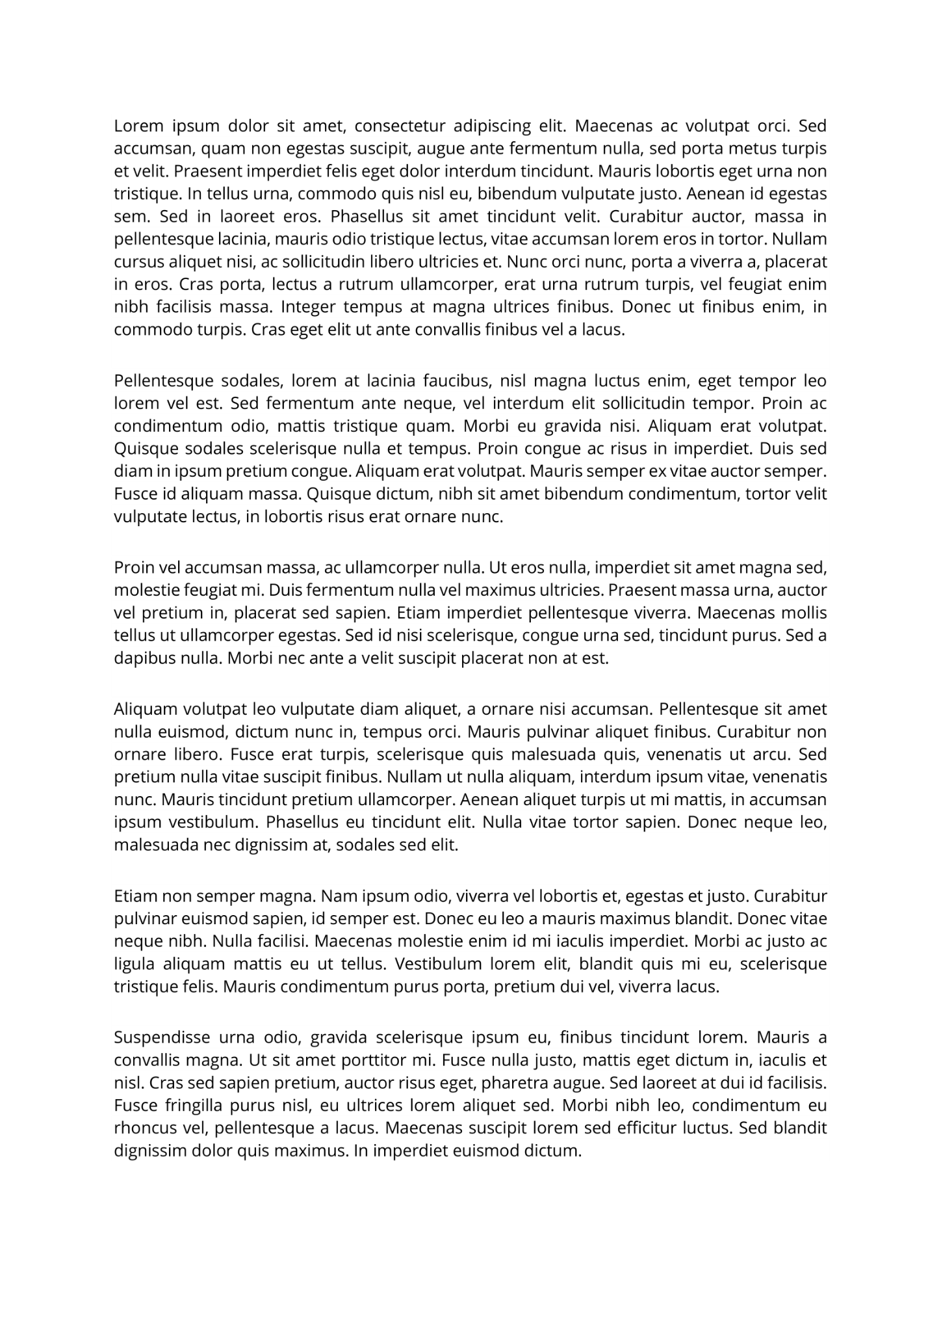

After extraction:

Paragraph_1

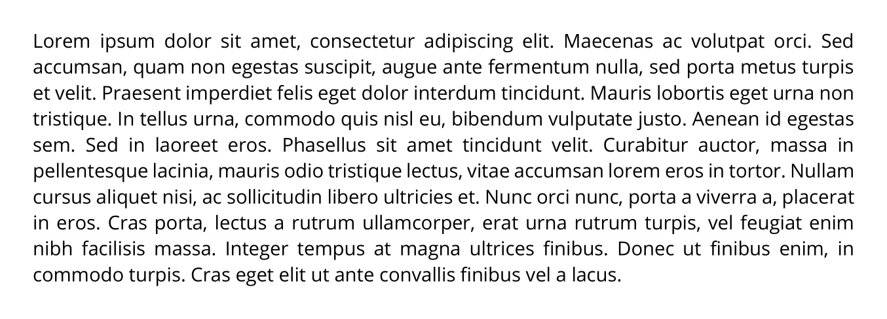

Paragraph_2

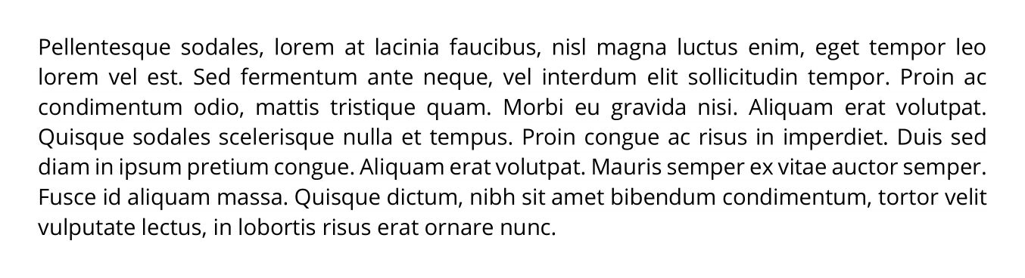

Paragraph_3

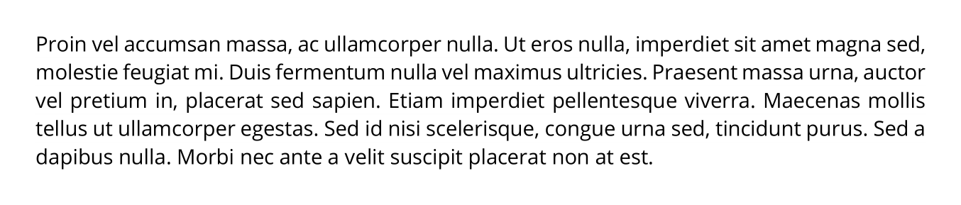

Paragraph_4

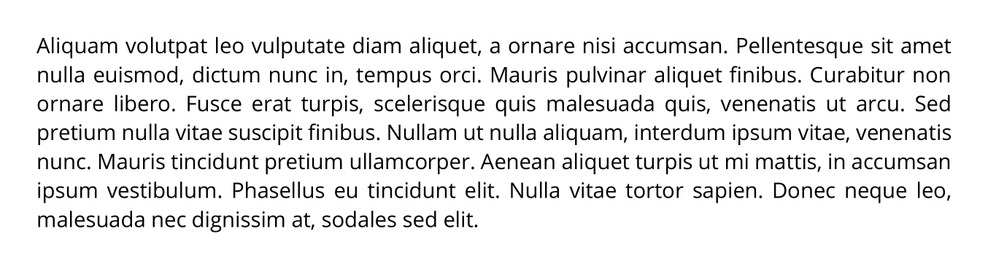

Paragraph_5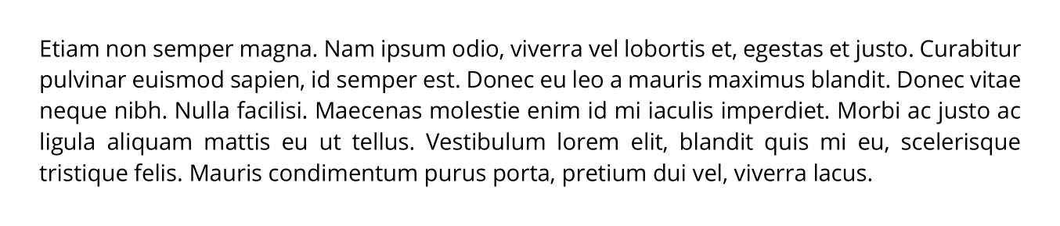

Paragraph_6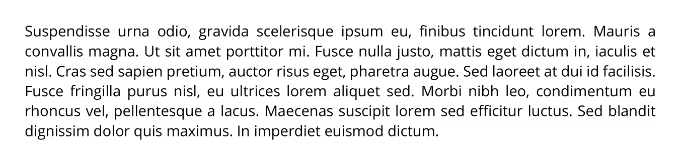

#### ***Sample output for image with 2 columns***

filepath: output/Material004

Before extraction:

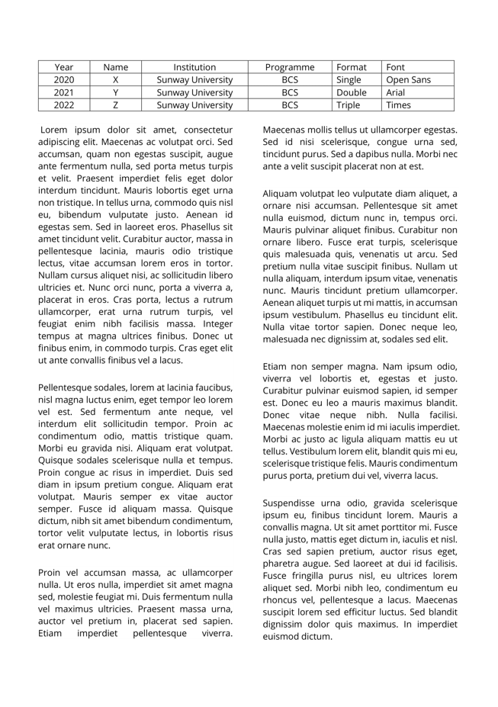

After extraction:

Paragraph_1

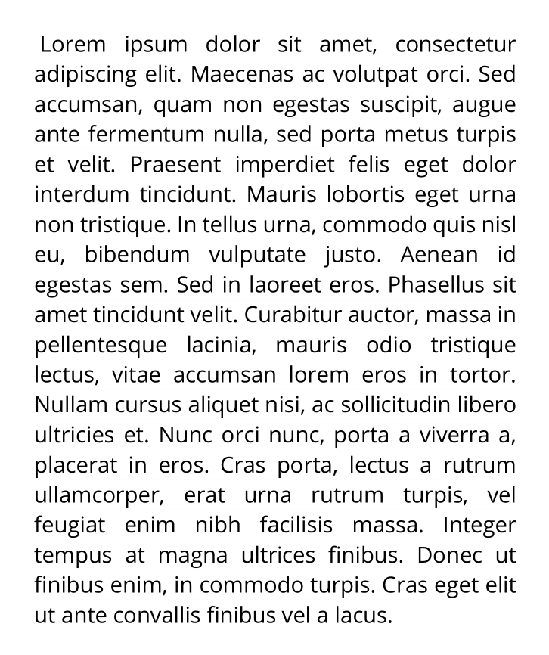

Paragraph_2

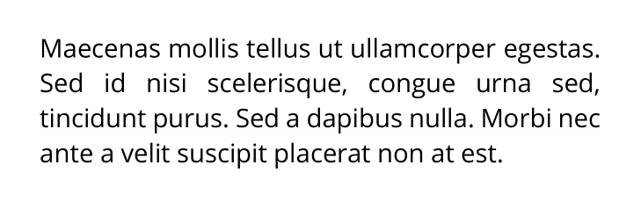

Paragraph_3

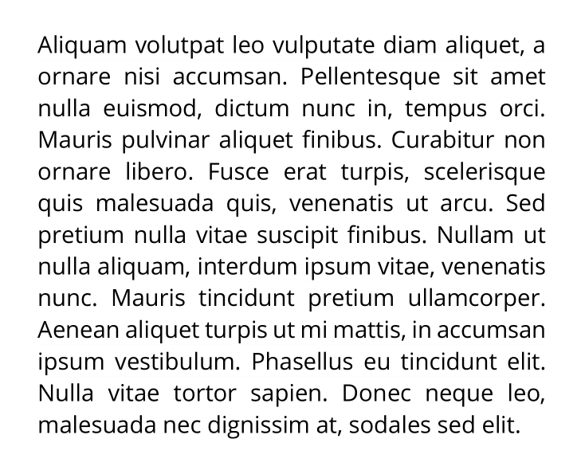

Paragraph_4

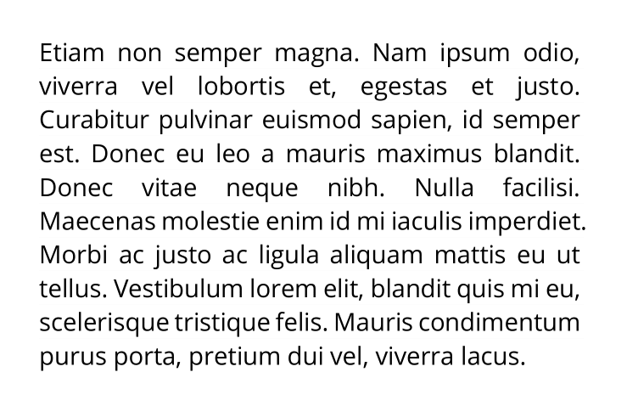

Paragraph_5

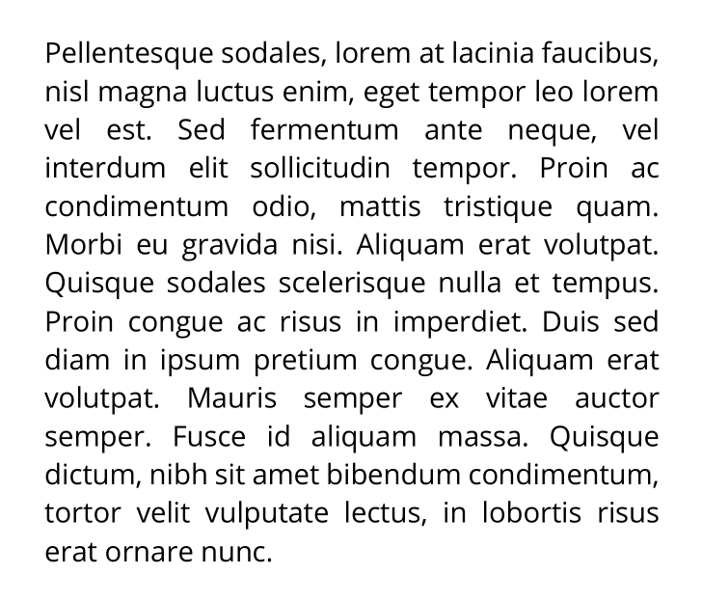

Paragraph_6

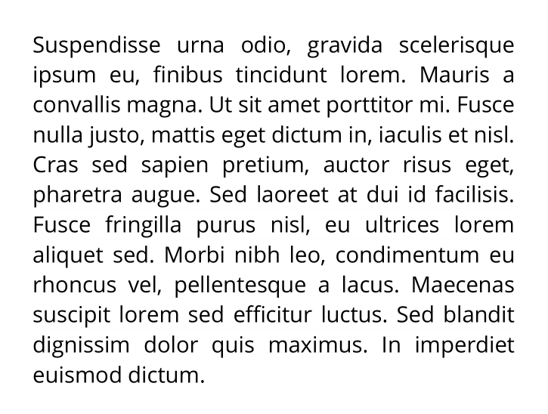

Paragraph_7

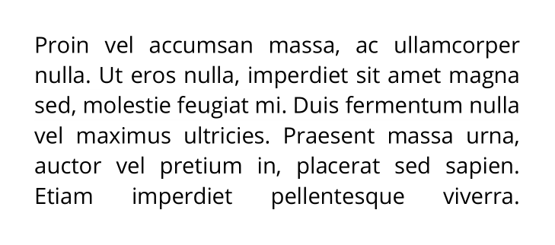

#### ***Sample output for image with 3 columns***

filepath: output/Material005

Before extraction:

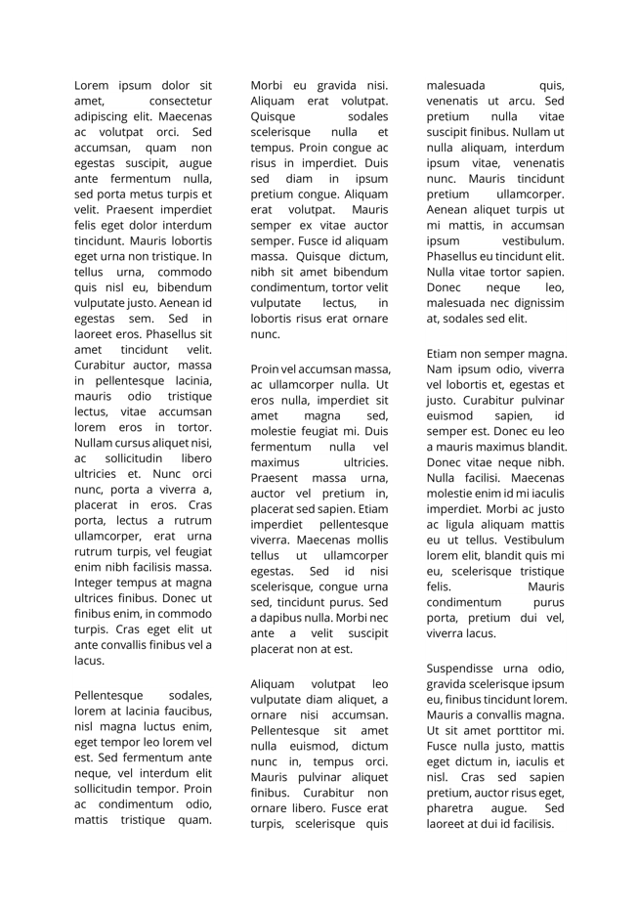

After extraction:

Paragraph_1

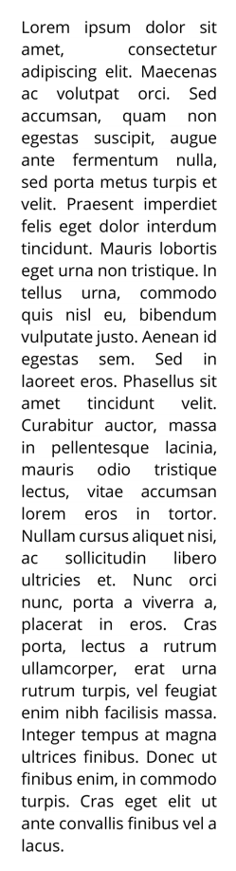

Paragraph_2

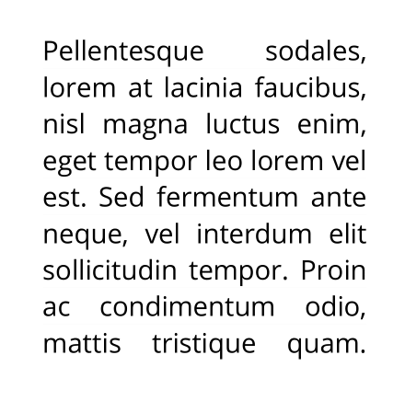

Paragraph_3

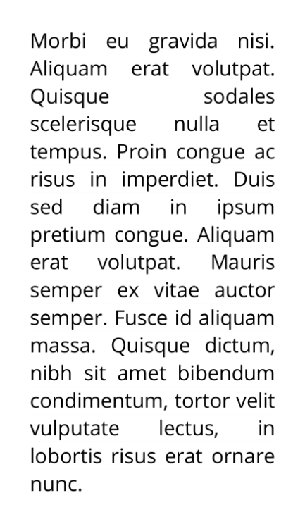

Paragraph_4

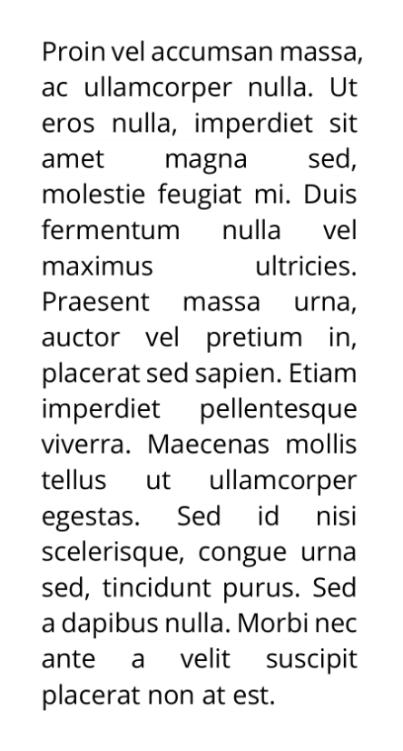

Paragraph_5

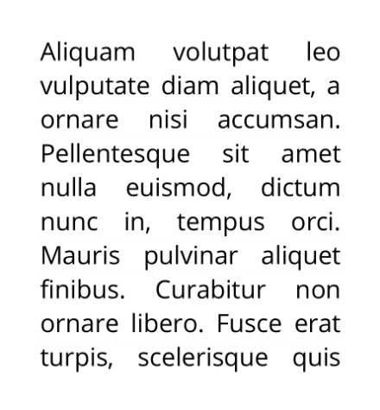

Paragraph_6

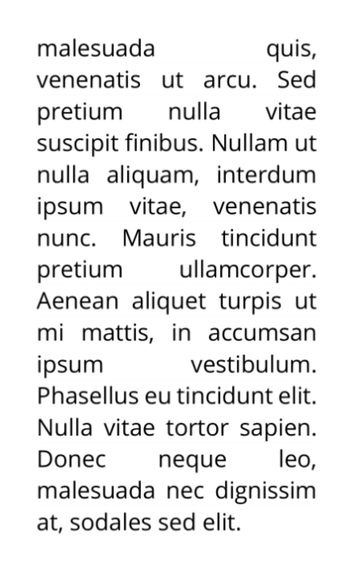

Paragraph_7

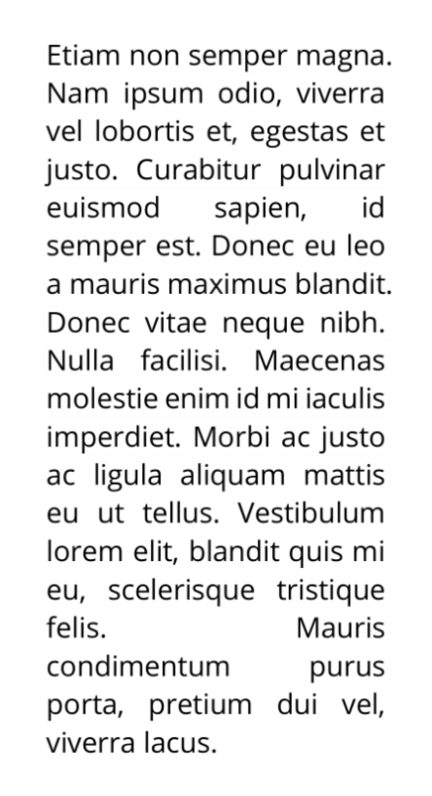

Paragraph_8

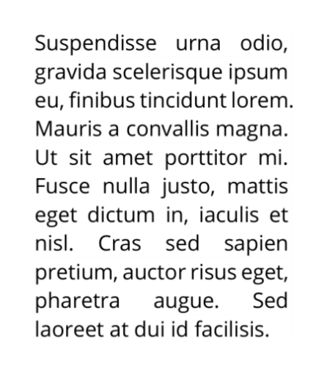

# **3.2 Discussion**

To conclude the assignment, we started by splitting part A and part B among our team. Communication is the key to efficient workflow and good output. We faced problems like not being on the same page and miscommunication over text messages throughout the assignment period and eventually worked our way around it. We learnt a lot of extra knowledge from the research and trial-and-errors by ourselves, being able to compare and contrast the difference between different methods and approaches in obtaining the same output. By researching and the knowledge obtained from previous lab classes on campus, we are able to accomplish the output desired and relate them back to the digital image processing theory that we have been taught. We also closely analyzed each output produced after each line/block of codes together and explained our own code to the rest of the team to make sure everyone in the team is clear and understood every part of the assignment fully.

# **3.3 Limitations**

Upon completion of the assignment, we discussed and identified several limitations that can be taken into consideration for future similar assignments. Firstly, during the rendering phase of part A, due to us processing the videos frame by frame, it is tedious for our laptop with an average of 8gb of ram to complete the show and write process efficiently. It took approximately 30 to 60 minutes for our script to render and obtain all three output videos. Other than that, sharing of files among teammates also brings down our overall efficiency as the zip file for everything is rather huge in size and sending of the files through WhatsApp takes a long time especially when some of the team members do not have stable internet connection.

For future assignments, it is good to consider a better approach of processing video or obtaining a device with higher specifications. Working in an environment with good internet connection is also an aspect to be considered or working together physically to ease the communication between team members and improve efficiency of the assignment workflow.

# 

# **3.4 References**

Datahacker.rs. (2020, August 15). *#001 how to read a video and access a webcam with opencv in python?* Master Data Science. Retrieved November 20, 2022, from https://datahacker.rs/001-how-to-read-a-video-and-access-a-webcam-with-opencv-in-python/

OpenCV. (n.d.). *Morphological transformations*. OpenCV. Retrieved November 20, 2022, from https://docs.opencv.org/4.x/d9/d61/tutorial_py_morphological_ops.html

# 

# **3.5 Turnitin Similarity Report**



 